41.29: a) Again using 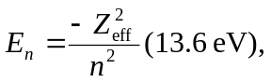 the outermost electron of the 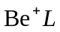 shell (n = 2) sees the inner two electrons shield two protons so 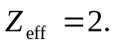
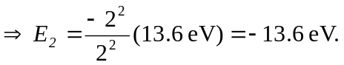
b) For 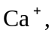 outer shell has n = 4, so 